___________________________
CONFIDENTIAL
CLIENT HISTORY & CONSENT FORM

Mind to Muscle
Remedial Massage

Name: ___________________________________________ Gender: M / F D.O.B: ____ /____ /_____
Address: ___________________________________________________________________PC___________________
Phone: (H) _________________________ (W) __________________________ (M)____________________________
E-mail: _________________________________________________________________________________________
Occupation_____________________________ Found m2mRM & Referred by________________________________
What activities (exercise/sport/hobbies) do you take part in? ______________________________________________
________________________________________________________________________________________________
Health Fund: __________________________________ 1st Massage? Y/N Last massage treatment______________

Have you ever had or do you currently have any of the following? (Place a tick to indicate “YES”)
Flu / cold/ Fever |  | High or low blood pressure |  | Diabetes
Dizziness |  | Heart, circulatory problems |  | Liver condition
Chronic pain |  | Abdominal/digestive problem |  | Kidney condition
Headaches/Migraines |  | Varicose veins |  | Rash, Athletes Foot/Tinea
Insomnia |  | Raised cholesterol |  | Skin disorders
Sleep apnoea |  | Blood clots |  | Shingles
Epilepsy |  | Lymphedema |  | Broken bones
Stroke |  | Asthma or lung condition |  | Osteoporosis
Arthritis |  | Motor vehicle accident |  | Joint injury/replacement
Depression |  | Chronic fatigue syndrome |  | Spinal injury
Allergies |  | Infectious condition/disease |  | Cancer/tumours
Numbness |  | Pregnancy |  | Muscle/ligament injury
Loss of Balance |  | Gout |  | Diagnosed Stress/Anxiety

If ticked yes or have ‘other’ please give details: ___________________________________________________________
__________________________________________________________________________________________________
List any recent injuries, operations or illnesses: ____________________________________________________________
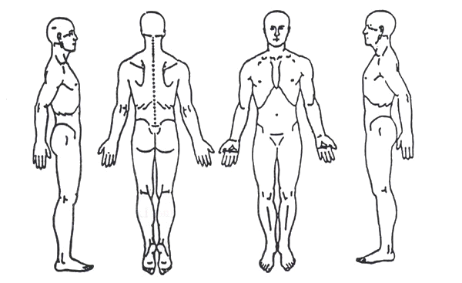
__________________________________________________________________________________________________
Please state any medication you are currently taking: ________________________
____________________________________________________________________
Presenting condition + area of pain/concern (circle or colour on diagram →): __________________________________
____________________________________________________________________
_____________________________________________________________________

CONSENT: I hereby give consent for a Mind to Muscle Remedial Massage.
Signature of client:_________________________________________________________ Date: ___ / ___ / ____

(Office use only) Practitioner Consent: I confirm that I have explained the treatment and plan for this client.
Signature of Therapist: ______________________________________________________ Date: ___ / ___ / ____

Please turn over and complete the next page as well.
©Mind to Muscle Remedial Massage 2017
_____________________________
IMPORTANT INFORMATION

Mind to Muscle Remedial Massage
Please read thoroughly, tick the adjacent box to acknowledge you agree, then sign and date at the bottom.
Payment, Bookings and Cancellations
□ I understand full payment fee is required on the day of consultation.
□ I understand that at least three hours’ notice needs to be given prior to making an appointment.
□ If I cancel my appointment on the same day it is scheduled I will be charge $30 Cancellation fee. The cancellation policy is in place to make sure appointments are kept available for others who need them and that you respect the Therapist Monique Nialls’ time.
□ If I fail to show up or cancel within an hour of my appointment, I will be charged the full (100%) appointment fee. Please understand that this is Monique Niall’s full-time job, she relies on her appointments to support herself and her business, cancelling within an hour or not showing up leaves her out of pocket with not enough time to fill that spot.
□ I appreciate that sometimes life can be unpredictable and short notice may be unavoidable, in such cases in situations out of client’s control, this policy will be advised and considered individually.
□ I understand that if I have any contagious condition, explicitly cold or flu, I will give Monique as much notice as possible. If arrive to appointment with any sign of sickness my appointment will be rescheduled, and I will be sent home.
Informed Consent and Waiver
□ I understand that a Therapist does not diagnose disease, illness, or prescribe any treatment or drugs, nor do they provide spinal manipulation.
□ I understand that there is always some risk associated with any treatment. The best way to reduce the chance of risk occurring is to answer all the questions asked (on this form and verbally) about your health, honestly and in detail.
□ I understand that the Therapist will explain the treatment before they commence, however I will ask if I require further explanation or have specific questions.
□ I understand that draping will be used always. If I become uncomfortable for any reason that I may ask the Therapist to end the massage session, and they will end the session.
□ I understand that the Therapist will end the session for any inappropriate behavior.
Privacy Statement
Any information that is obtained regarding my current health and progress will be kept confidential and will not be provided to any person other than relevant health care professionals without my expressed written consent.
□ I understand the Therapist does collect personal information when services are provided. When personal information is collected (as defined in the Privacy Act) such as health information, it will be to acknowledge and tailor a suitable service.
□ I understand personal information is kept safe from misuse, loss or unauthorized use or disclosure by implementing a variety of security measures.
I acknowledge and warrant that all information I have provided on this form is true and correct. I have read, agreed and understand the information provided, and allow treatment to be received by Mind to Muscle Remedial Massages’ qualified Therapist.
Name:________________________________________ Signature: _________________________ Date: ___ / ___ / ____
If a client is under 18, a parent or guardian’s signature is required.

